Final Exam Review: Math 2201
Q1 Given the conic $9x^{2}+24xy+16y^{2}-30x-40y=0.$Do the following:
(a) Find the angle of rotation required to eliminate the $xy$-term.
(b) Write the transformation equations between $\left(x , y\right)$and $\left(X , Y\right)$.
(c) Transform the equation into the $X,Y$coordinate system.
(d) Translate the origin if necessary to put the equation into standard form.
(e) Identify the conic.
(f) Find its vertex/vertices and other relevant geometric properties.

Q2 Consider $13x^{2}+10xy+13y^{2}=72.$
- Find the angle of rotation that eliminates the $xy$-term.
- Find the transformed equation.
- Identify the conic.
- Find its semi-major and semi-minor axes.
Q3 A point has polar coordinates $\left(r , θ\right)=\left(6 , \frac{2π}{3}\right)$ and $z=4$. Find
- Cartesian coordinates.
- Cylindrical coordinates.
- Distance from the $z$-axis.
- Distance from the origin.
Q4
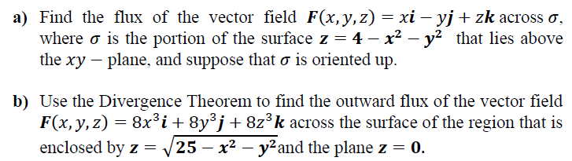
Q5
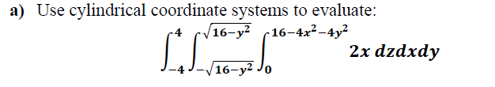

Q6
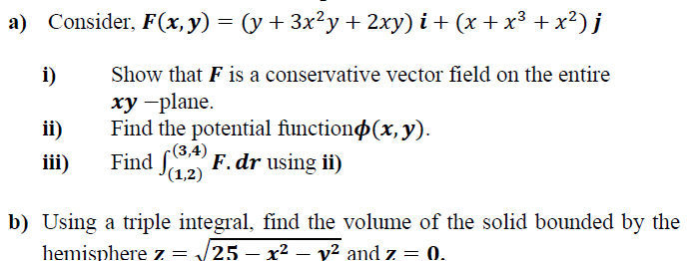
Q7
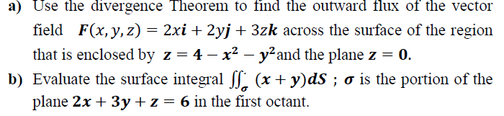
Q8
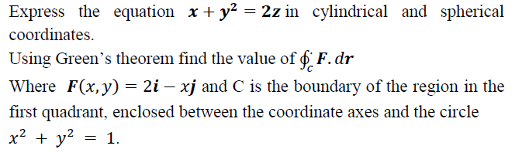
Q9
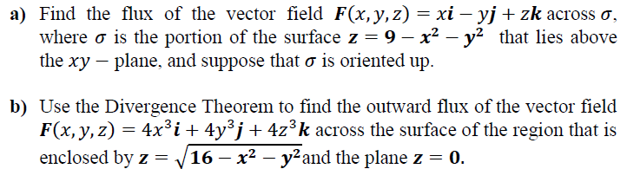

Q10
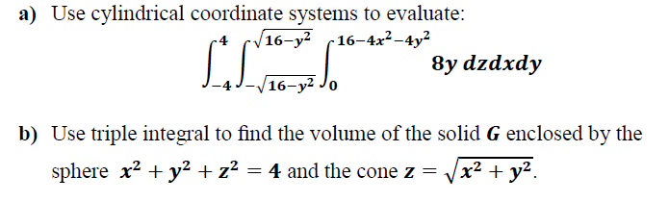
Q11
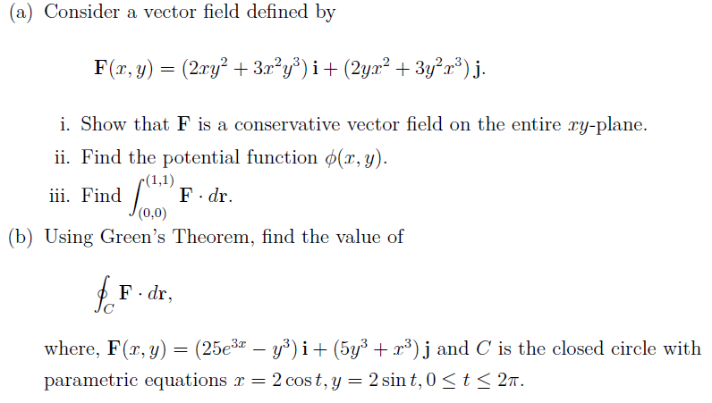
Q12
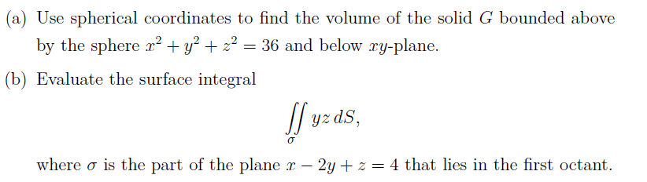

Q13
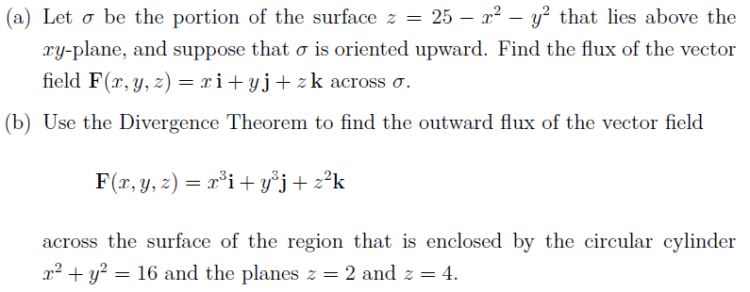
Q14
The temperature at a point (x, y, z ) is given by At the point (P(1,-1,2), find the rate at which temperature increases in the direction from P toward Q(3,2,3).
Q15
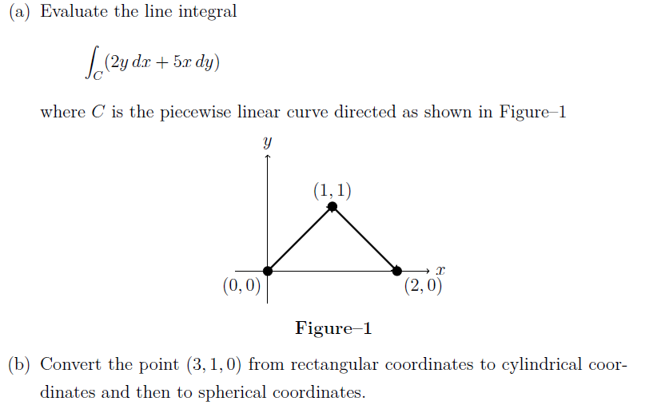

Q16
The scalar field f (x, y, z) represents a physical quantity in space, where,
(a) Find 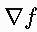
(b) Find the gradient at (P(1,2,-1)
(c) Explain what the direction of at represents physically.

